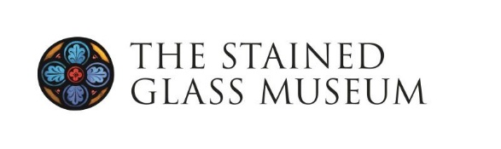
Study Tour - York

Sunday 19 - Wednesday 22 April 2026

Programme
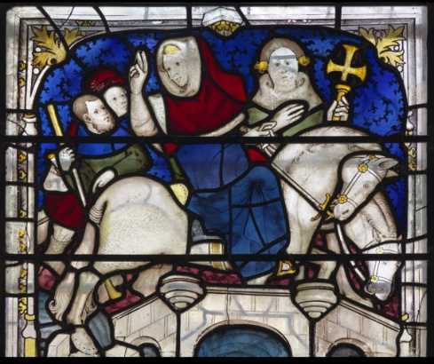
Our 2026 Study Tour will explore stained glass to be seen in and around the city of York on foot, as well as in the East Riding of Yorkshire, with a rare opportunity to be guided by resident experts. Whilst the medieval treasures of York Minster and the city’s parish churches are renowned, this visit will provide an opportunity to visit recently conserved windows at All Saints, North Street, York Minster, and St Denys, as well as the new Centre of Excellence for Heritage Craft Skills opened in 2025. We will visit two leading studios for the conservation of historic and creation of new stained glass – York Glaziers Trust and Barley Studios In addition, we will see windows by prominent York makers including Georgian glass-painter William Peckitt (1731-1795), 20th century glass artists Harry Stammers (1902-1969), Harry Harvey (1922-2011), and Helen Whittaker. By coach, we will visit less-well-known windows in the region by 19th century Belgian glass-painter Jean-Baptiste Capronnier, as well as Douglas Strachan (1875-1950) and Alf Fisher.
Workshop of John Thornton, ‘The Miracle of Ouse bridge’, St William Window, c.1414 ©York Minster

Fitness: Most days will be led on foot. Whilst we will plan to reduce walking distances between sites as much as we can, you will need to have reasonable fitness to walk across and around the city.

Dates
Registration will start at the earlier time of 1-2pm on Sunday 19 April 2026, followed by a couple of visits and an introductory talk before our group dinner. Site visits will continue all day on Monday and Tuesday with an earlier finish on Wednesday, by 2pm on Wednesday 22 April 2025.

Travel
York is easily accessible by train from various parts of the country with a direct train available from London via the East Coast main line and via the West, Midland and Cross County main lines.
Our accommodation at Middleton’s Hotel, York, is less than 1 mile from the train station and a 15-minute walk or short taxi-ride away. There is limited free parking at the hotel. Or, in the event the carpark is full, there are several public carparks a few minutes’ walk away, however, these are chargeable.

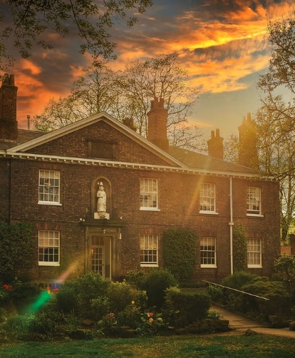
Accommodation and Dining
We will stay at the Middleton’s Hotel, Cromwell Road, York, YO1 6DS, within the historic city walls. This 4-star hotel benefits from modern facilities, including Wi-Fi throughout, a gym and an award winning restaurant, whilst the hotel occupies six historic, grade II listed buildings including the old Organ Factory, originally the workshop of York’s master organ builder Walter Hopkins, who retired in 1921.
Accommodation packages include three nights’ accommodation and evening meals for Sunday, Monday and Tuesday nights. Extra nights on Saturday or Wednesday can be booked at an additional cost. On Sunday and Tuesday we will dine at the hotel, and on Monday evening we will have an exclusive dinner at the Merchant Adventurer’s Hall – an original timber-framed medieval guildhall and scheduled ancient monument which is home to The Company of Merchant Adventurers of the City of York, founded in the 14th century.

Guides
Guiding on site will be led by a group of experienced guides including Prof. Tim Ayers (Corpus Vitrearum), Keith Barley MBE (Barley Studios), Prof. Sarah Brown (University of York), and Dr Jasmine Allen (Director and Curator).

Prices (per person)
Residential – Friends of the Museum:
£650 Single occupancy (inc. three nights bed & breakfast & evening meals Sun, Mon, and Tue)
£600 Double/twin occupancy (inc. three nights bed & breakfast & evening meals Sun, Mon, and Tue)
Residential – Non-Friends of the Museum:
£675 Single occupancy (inc. three nights bed & breakfast & evening meals Sun, Mon, and Tue)
£625 Double/twin occupancy (inc. three nights bed & breakfast & evening meals Sun, Mon, and Tue)

Non-residential:
A limited number of non-residential places are available, and include coach travel, site notes but not accommodation, breakfast or evening meals. Non-residential delegates are welcome to join us at the Merchants Hall on Monday night for dinner.
£250 per person (Friends of the Museum)
£275 per person (non-Friends of the Museum)

How to Book
Please complete the Booking Form (1 page) and ICE Form (1 page) on the following pages and return to Emily Allen by email to events@stainedglassmuseum.com
Or by post to The Stained Glass Museum, The South Triforium, Ely Cathedral, Ely, CB7 4DL.

Payments (both deposit and full balances) can be made by BACS or by cheque

Additional info

We know one of the things people particularly enjoy about The Stained Glass Museum’s study tours is meeting such a friendly, welcoming group of people, who share many of the same interests. So this year, we have included an additional section on the booking form in case you would like us to share any information about your background or interests with other delegates.

Examples:

I am a working artist and particularly interested in medieval stained glass. This is my second study tour.
In my retirement, I have conducted extensive research into the stained glass of Cambridgeshire and the surrounding areas. I have been attending the study tour most years since the mid 2000s. I am a Freeman of Worshipful Company of Glaziers.
This is my first study tour and I have developed an interest in glass over recent years but am keen to learn more about it. I am particularly looking forward to seeing Arts and Crafts glass.

York Study Tour Booking Form
Sunday 19 – Wednesday 22 April 2026
Name(s):
Please give details of any special dietary requirements or access requirements for the hotel (continue overleaf if needed):
Address:

Email Address:
Mobile Tel: (contact during event):

Package Type:
Accommodation will be provided for three nights - Sun 19 April, Mon 20 April, and Tue 21 April 2026.
Package - Friends of the Museum Delegate | # | Package – Regular Delegate | #
Single occupancy ∙ Friends rate ∙ £650 per person |  | Single occupancy delegate ∙ £675 per person
Double occupancy ∙ Friends rate ∙ £600 per person |  | Double occupancy delegate ∙ £625 per person
Twin occupancy ∙ Friends rate ∙ £600 per person |  | Twin occupancy delegate∙ £625 per person
Non-residential ∙ Friends rate ∙ £250 per person |  | Non-residential delegate ∙ £250 per person

Optional extra nights required on a bed and breakfast basis (no evening meal). Please note costs below are extra per room and are subject to availability.

Sat 18 April @ £155 B&B (single) £165 B&B (double/twin)

Wed 22 April @ £155 B&B (single) £165 B&B (double/twin)
Yes / No
I consent to my name and email address to be included on the delegate list

Your interests/background. If you would like us to share any information about your background, associations or interests with other delegates, please note these here:

Insurance & Liability:
I understand that I am responsible for making my own travel insurance arrangements, and The Stained Glass Museum will not be liable for any injury, loss or damage arising from my participation in this event.

Donation:
I would like to give a donation of £………………towards a student place on the Study Tour

Deposit & Payment:
I enclose a cheque made out to The Stained Glass Museum for the sum of

£……………………… (A deposit of £250 per person is required on booking).
OR
I have paid the above amount by BACS on……………..(date)

The Stained Glass Museum Account No. 00031285 Sort code: 405240
(please notify us by email to events@stainedglassmuseum.com when making a BACS payment)
Full payment is due by 28 February 2026. Please note your deposit is non-refundable and due by 27 December 2025. There will be no refund if you cancel on / after this date.
Study Tour – ICE Form

Name of Delegate

Mobile no. of Delegate

Medical issues/history
If you currently on any medication, suffer from a medical condition, have a serious allergy, disability or reduced mobility, please tell us before making your booking so that we can assist you in considering the suitability of the arrangements and in order that we can assess the potential risks to your welfare and health and safety. In the case of an emergency this information will be passed on to the Emergency Services.

In case of an emergency, who should we contact?
Name
(relationship)
Phone number
Mobile phone
Address

I understand that this information will be temporarily held by the Stained Glass Museum until the end of the 2026 Study Tour. I consent to this information being passed on to Emergency Services in the event of an emergency, so that they can assist.

Name: …………………………………………………………………..

Signature Date : ……………………

Data Protection and Confidentiality: This information will only be stored by The Stained Glass Museum for use during the 2026 Study Tour and will only be disclosed to emergency services should you require medical attention. After the weekend the data will be destroyed.

